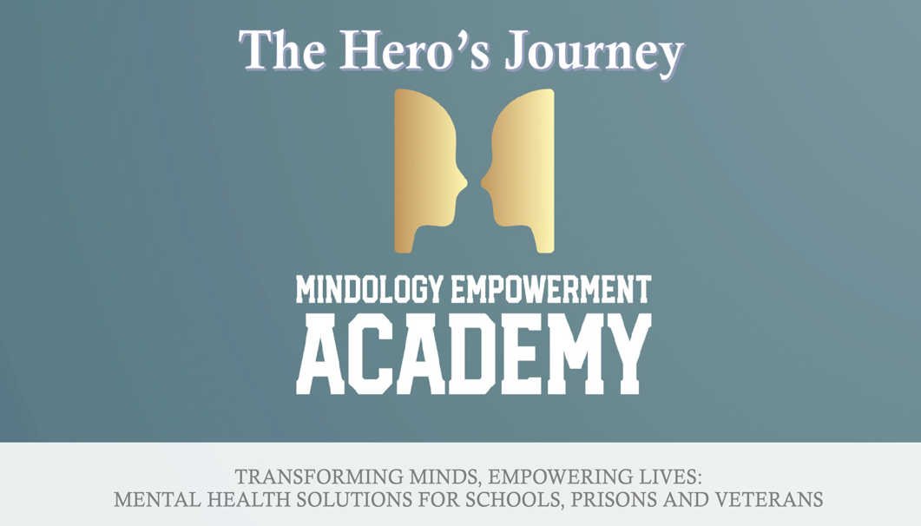

*"Dr. Troy You are going to do great things in correctional facilities all over the US. I am glad we are being blessed first." --* K.Camacho, Rentry Program Manager, Harris County, Texas

**Mindology Empowerment Academy** **Healing Undesirable Emotions, one L.A.P. at a time**

A transformative program designed by **Dr. Troy Byer**, Mindology Empowerment Academy offers incarcerated individuals the tools to heal emotionally, rebuild their identities, and reclaim their futures.

**Key Components of the Program:**

1. **Identity Reconstruction (First L.A.P.)**
   * Participants dismantle harmful “default identities” shaped by trauma and rebuild healthier, empowered ones.
2. **Emotional Wellness Curriculum (4 Week L.A.P. Cycles)**
   * Each week focuses on one Undesirable Emotion (U.E.): **anxiety, anger, fear & sadness.**
   * Participants explore how these emotions affect key relationships (e.g., parents, significant others, authority figures).
3. **Future Visioning (Final L.A.P.)**
   * Participants script the life they want to create, writing from the perspective of the future, looking back on ten years of success and transformation

**Why Mindology Works**

**Delivered 100% Online:**  
Created by clinical psychologist, Dr. Troy Byer. Scalable, consistent, and cost-effective for institutions nationwide.

* **Mind Champs: The Backbone of the Program**
  + Mind Champs are trained mentors with both lived experience and professional training, offering guidance and emotional support throughout the program.
  + Participants receive personalized coaching and group support, ensuring they stay engaged and on track.
* **Proven Techniques:**
  + Incorporates **mindfulness**, **problem resolution, movement**, **creative expression**, and **science-based strategies** for emotional regulation.
* **Long-Term Support:**
  + After completing the 18 week program, participants can become **Community "Peer" Champs**, mentoring others while preparing for a potential career as life coaches.